

AGRICULTURE CROPS IN INDIA 1197-2021

**Submitted by:**

1. **PAGADALA PRUDHVI**
2. **PINJARI SAMEER BASHA**
3. **SHAIK SHASHA VALI**
4. **SYED SARMAS VALI**
5. **VARADHI SHASHANK**
6. **AVIRIN SHASHANK**

**India Agriculture Crop Production Analysis ( 1197-2021)**

This report delves into the captivating realm of India's agricultural cultivation, providing a comprehensive visual exploration of key aspects and trends in the agricultural sector. Through the visual representations, readers can gain valuable insights into crop production, seasonal variations, regional distribution, and overall production trends. These visualizations enable intuitive analysis, allowing stakeholders to uncover patterns, identify areas of growth or concern, and make data-driven decisions.

By harnessing the power of Tableau, this report not only presents the data in a visually appealing manner but also provides an interactive experience for readers to explore the intricacies of India's agricultural cultivation. To Extract the Insights from the data and put the data in the form of visualizations, Dashboards and Story we employed TablProblems of Indian Agriculture.

**Problems of Indian Agriculture**

Indian agriculture faces challenges including erratic rainfall, inadequate irrigation, soil degradation, diverse cultivation methods, improper crop techniques, and diminishing arable land. These factors collectively impact agricultural productivity, highlighting the need for sustainable solutions to ensure food security and rural livelihoods.

Certain regions in India are grappling with the adverse consequences of excessive water extraction for agricultural purposes, causing a decline in groundwater levels. Conversely, water-logging issues in specific irrigated zones are resulting in the accumulation of soil salts.

Variable and unpredictable rainfall patterns.

Insufficient availability of irrigation infrastructure.

Erosion of soil quality over time.

Various approaches to farming and cultivation.

Flawed techniques employed in crop cultivation.

Decrease in the overall area of land used for cultivation.

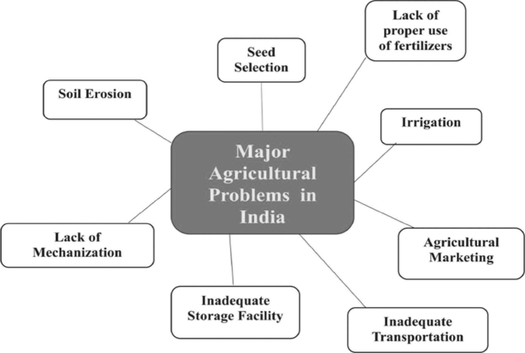

**Problems of Indian Agriculture - Main Four Factors**

The challenges facing Indian agriculture encompass four key factors: environmental, economic, institutional, and technological. Climate change, unpredictable monsoons, and soil degradation contribute to vulnerability. Economic struggles include low income, credit access issues, and market volatility. Inefficient institutions hinder progress through complex land ownership and tenure systems. A technological gap with outdated practices and limited modern adoption hampers productivity. Addressing these factors is crucial for a resilient and prosperous agricultural sector.

Environmental Factors

The environmental challenges posed to Indian agriculture are multifaceted. Climate change, unpredictable monsoons, water scarcity, soil degradation, and loss of biodiversity all contribute to the vulnerability of the agricultural sector. The increasing frequency of extreme weather events disrupts crop cycles and reduces overall productivity.

Economic Factors

Economic issues plague Indian agriculture as well. Farmers often grapple with low income levels, lack of access to credit, and market volatility. The absence of fair pricing mechanisms further exacerbates the economic strain on agricultural practitioners, pushing many into debt and financial instability.

Institutional Factors

Inefficient and outdated institutional frameworks hinder agricultural progress in India. Inadequate land reforms, complex land ownership regulations, and cumbersome land tenure systems make it difficult for farmers to access and utilize land effectively. This institutional inefficiency perpetuates inequality and limits agricultural development.

Technological Factors

The technological gap in Indian agriculture is a significant concern. Outdated farming practices and limited adoption of modern technologies result in suboptimal yields and productivity. The absence of mechanization, inadequate irrigation systems, and lack of access to quality seeds and fertilizers further contribute to technological stagnation.

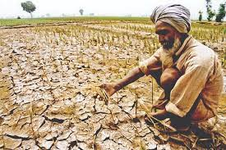 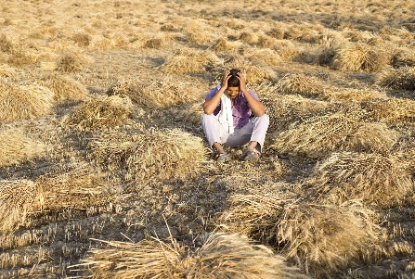

**MAJOR PROBLEMS FACED BY INDIAN AGRICULTURE**

Small and fragmented land holdings, Seeds, Manures, Fertilisers and Biocides, Irrigation, Lack of mechanisation, Soil erosion, Agricultural Marketing and Scarcity of capital are among the major problems faced by Indian Agriculture.

Land Access and Ownership: Access to suitable agricultural land is fundamental. Clear land ownership rights or secure leasing arrangements are essential for long-term planning and investment.

**BUSINESS REQUIREMENTS**

**Water Resources**: Access to reliable water sources for irrigation is critical, especially in regions prone to drought or erratic rainfall. Investments in water conservation, irrigation infrastructure, and rainwater harvesting can be necessary.

**Seeds and Inputs**: High-quality seeds, fertilizers, pesticides, and other agricultural inputs are necessary to ensure productivity and crop quality. Access to these inputs at reasonable prices is crucial for farmers.

**Technology Adoption**: Embracing modern agricultural practices and technology can enhance productivity and efficiency. This includes mechanization, precision agriculture, use of genetically modified seeds, and adoption of IoT (Internet of Things) devices for monitoring and management.

**Access to Credit and Finance**: Adequate financial resources are required for purchasing inputs, equipment, and for managing operational expenses. Access to credit at reasonable interest rates, insurance products tailored for agriculture, and other financial services are vital for farmers.

**Market Access and Infrastructure**: Efficient transportation, storage, and market infrastructure are essential for getting produce to consumers in a timely and cost-effective manner. Developing cold storage facilities, warehouses, and improving rural road networks can help reduce post-harvest loss and improve market access**.**

**Information and Extension Services**: Access to timely and accurate information on weather forecasts, market prices, crop management techniques, and government schemes is crucial. Extension services provided by agricultural universities, research institutions, and government agencies play a vital role in disseminating knowledge and best practices.

**Policy Support**: Favorable government policies and regulatory frameworks can significantly impact the agricultural business environment. Policies related to land acquisition, crop pricing, minimum support prices (MSP), subsidies, and export-import regulations can influence profitability and sustainability.

**Sustainable Practices**: Increasingly, consumers are demanding sustainably produced agricultural products. Practices that promote soil health, water conservation, biodiversity conservation, and reduced chemical usage are becoming more important for long-term viability and market acceptance.

**Market Intelligence and Diversification**: Understanding market trends, consumer preferences, and potential opportunities for crop diversification or value addition is essential for making informed business decisions and maximizing returns.

**LITERATURE SURVEY**

The literature survey section of the report provides a concise overview of India's agricultural sector, focusing on key aspects and insights from existing studies and publications. It examines the historical context of agricultural practices in India and highlights the role of government policies and initiatives in supporting the sector's growth and development.

The survey explores the diversity of crops cultivated across different regions, along with trends in production and the impact of climate variability. It also addresses the adoption of technology and innovation in agriculture, along with the challenges faced by farmers and potential research gaps.

Additionally, the section showcases best practices and success stories that have contributed to improved productivity and sustainability in Indian agriculture. This literature review forms the basis for the subsequent analysis and visualization of agricultural data in the report.

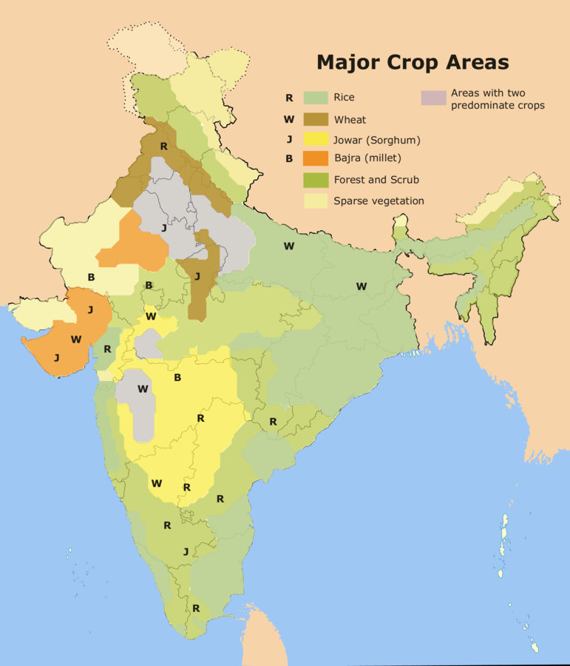

**Social Or Business Impact**

**Social Impact:** On the social front, agriculture serves as a vital source of livelihood for a large portion of the population, especially in rural areas. It plays a crucial role in ensuring food security and alleviating poverty by providing employment opportunities and income generation. Moreover, agricultural activities contribute to the overall socio-economic development of rural communities, fostering social cohesion and preserving cultural traditions.

**Business Impact**: From a business perspective, the agricultural sector plays a pivotal role in India's economy. It contributes to the country's GDP and serves as a source of raw materials for various industries, such as food processing, textile, and pharmaceuticals. The growth and productivity of the agricultural sector have direct implications for the overall economic performance and stability of the nation. Furthermore, advancements in agricultural practices and technology have the potential to enhance productivity, optimize resource utilization, and promote sustainable practices. This, in turn, can lead to increased profitability and competitiveness for agricultural businesses.

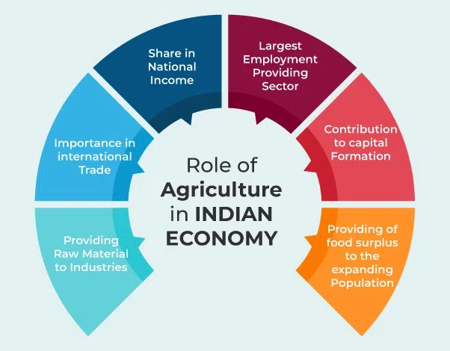

Social wise the farmers worried much about the climatic changes, rains, soil erosion etc but the business impact is not imaginable become sometimes the prices go higher and sometimes goes low so the business impact is not depended upon farmers it depends on people.

**DATA COLLECTION OF INDIAN AGRICULTURE CROP**

**HISTORY OF INDIAN AGRICULTURE**

The history of agriculture in India dates back to the Neolithic period. India ranks second worldwide in farm outputs. As per the Indian economic survey 2020 -21, agriculture employed more than 50% of the Indian workforce and contributed 20.2% to the country's GDP.

In 2016, agriculture and allied sectors like animal husbandry, forestry and fisheries accounted for 17.5% of the GDP (gross domestic product) with about 41.49% of the workforce in 2020.India ranks first in the world with highest net cropped area followed by US and China. The economic contribution of agriculture to India's GDP is steadily declining with the country's broad-based economic growth. Still, agriculture is demographically the broadest economic sector and plays a significant role in the overall socio-economic fabric of India.

The total agriculture commodities export was US$3.50 billion in March - June 2020. India exported $38 billion worth of agricultural products in 2013, making it the seventh-largest agricultural exporter worldwide and the sixth largest net exporter. Most of its agriculture exports serve developing and least developed nations. Indian agricultural/horticultural and processed foods are exported to more than 120 countries, primarily to the Japan, Southeast Asia, SAARC countries, the European Union and the United States.

As per the 2014 FAO world agriculture statistics India is the world's largest producer of many fresh fruits like banana, mango, guava, papaya, lemon and vegetables like chickpea, okra and milk, major spices like chili pepper, ginger, fibrous crops such as jute, staples such as millets and castor oil seed. India is the second largest producer of wheat and rice, the world's major food staples.

India is currently the world's second largest producer of several dry fruits, agriculture-based textile raw materials, roots and tuber crops, pulses, farmed fish, eggs, coconut, sugarcane and numerous vegetables. India is ranked under the world's five largest producers of over 80% of agricultural produce items, including many cash crops such as coffee and cotton, in 2010. India is one of the world's five largest producers of livestock and poultry meat, with one of the fastest growth rates, as of 2011.

**Late Middle Ages (1200–1526 )**

The construction of water works and aspects of water technology in Medieval India is described in Arabic and Persian works. The diffusion of Indian and Persian irrigation technologies gave rise to an irrigation systems which brought about economic growth and growth of material culture. Agricultural 'zones' were broadly divided into those producing rice, wheat or millets. Rice production continued to dominate Gujarat and wheat dominated north and central India.

Sugar mills appeared in India shortly during this era. Evidence for the use of a draw bar for sugar-milling appears at Delhi in 1540, but may date back earlier, and was mainly used in the northern Indian subcontinent. Geared sugar rolling mills later appeared in Mughal India, using the principle of rollers as well as worm gearing, by the 17th century.

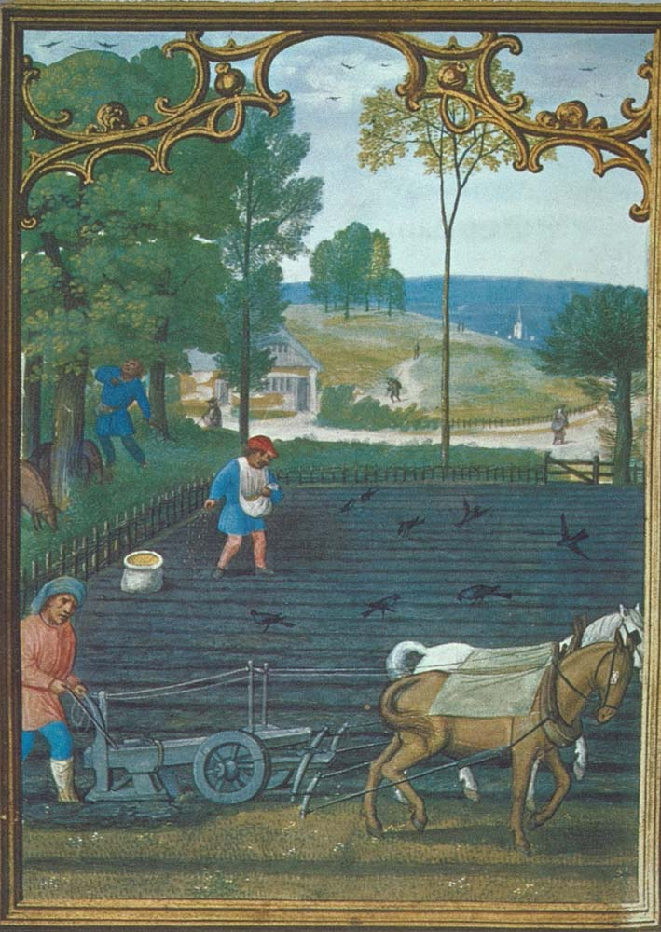

**Mughal Era (1526–1757 )**

Indian agricultural production increased under the Mughal Empire, during which India's population growth accelerated. A variety of crops were grown, including food crops such as wheat, rice, and barley, and non-food cash crops such as cotton, indigo and opium. By the mid-17th century, Indian cultivators begun to extensively grow two new crops from the Americas, maize and tobacco.

Land management was particularly strong during the regime of Akbar the Great (reigned 1556–1605), under whom scholar-bureaucrat Todarmal formulated and implemented elaborated methods for agricultural management on a rational basis. Indian crops—such as cotton, sugar, and citric fruits—spread visibly throughout North Africa, Islamic Spain, and the Middle East. Though they may have been in cultivation prior to the solidification of Islam in India, their production was further improved as a result of this recent wave, which led to far-reaching economic outcomes for the regions involved.

The Mughal administration emphasized agrarian reform, which began under the Sur emperor Sher Shah Suri, the work of which Akbar adopted and furthered with more reforms. The civil administration was organized in a hierarchical manner on the basis of merit, with promotions based on performance. The Mughal government funded the building of irrigation systems across the empire, which produced much higher crop yields and increased the net revenue base, leading to increased agricultural production.

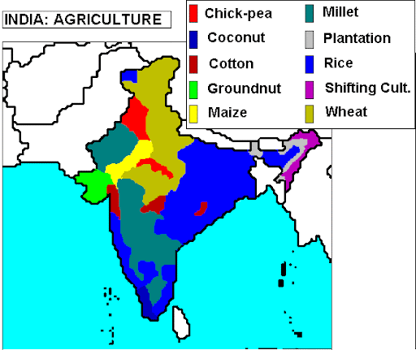

Indian agriculture was advanced compared to Europe at the time, such as the common use of the seed drill among Indian farmers before its adoption in European agriculture. While the average farmer across the world was only skilled in growing very few crops, the average Indian farmer was skilled in growing a wide variety of food and non-food crops, increasing their productivity. Indian farmers were also quick to adapt to profitable new crops, such as maize and tobacco from the New World being rapidly adopted and widely cultivated across Mughal India between 1600 and 1650. Bengali farmers rapidly learned techniques of mulberry cultivation and sericulture, establishing Bengal Subah as a major silk-producing region of the world.

**Colonial British Era (1757–1947 )**

Few Indian commercial crops—such as Cotton, indigo, opium, wheat, and rice—made it to the global market under the British Raj in India. The second half of the 19th century saw some increase in land under cultivation and agricultural production expanded at an average rate of about 1% per year by the later 19th century. Due to extensive irrigation by canal networks Punjab, Narmada valley, and Andhra Pradesh became centres of agrarian reforms. Roy (2006) comments on the Influence of the world wars on the Indian agricultural system:

Agricultural performance in the interwar period (1918–1939) was dismal. From 1891 to 1946, the annual growth rate of all crop output was 0.4 %, and food-grain output was practically stagnant. There were significant regional and intercrop differences, however, nonfood crops doing better than food crops. Among food crops, by far the most important source of stagnation was rice. Bengal had below-average growth rates in both food and nonfood crop output, whereas Punjab and Madras were the least stagnant regions. In the interwar period, population growth accelerated while food output decelerated, leading to declining availability of food per head. The crisis was most acute in Bengal, where food output declined at an annual rate of about 0.7 % from 1921 to 1946, when population grew at an annual rate of about 1 %.

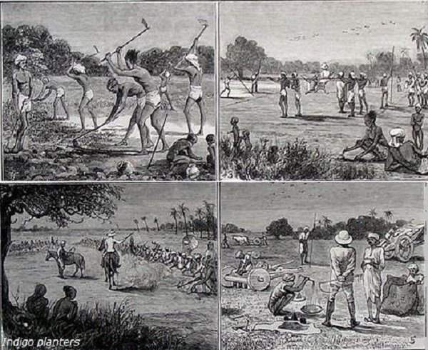

**Republic of India (1947 onwards)**

Bhakra Dam (completed 1963) is the largest dam in India.

Special programmes were undertaken to improve food and cash crops supply. The Grow More Food Campaign (1940s) and the Integrated Production Programme (1950s) focused on food and cash crops supply respectively. Five-year plans of India—oriented towards agricultural development—soon followed. Land reclamation, land development, mechanisation, electrification, use of chemicals—fertilisers in particular, and development of agriculture oriented 'package approach' of taking a set of actions instead of promoting single aspect soon followed under government supervision.The many 'production revolutions' initiated from 1960s onwards included Green Revolution in India, Yellow Revolution (oilseed: 1986–1990), Operation Flood (dairy: 1970–1996), and Blue Revolution (fishing: 1973–2002) etc. Following the economic reforms of 1991, significant growth was registered in the agricultural sector, which was by now benefiting from the earlier reforms and the newer innovations of Agro-processing and Biotechnology.

Since independence, India has become one of the largest producers of wheat, edible oil, potato, spices, rubber, tea, fishing, fruits, and vegetables in the world. The Ministry of Agriculture oversees activities relating to agriculture in India. Various institutions for agriculture related research in India were organised under the Indian Council of Agricultural Research (est. 1929). Other organisations such as the National Dairy Development Board (est. 1965), and National Bank for Agriculture and Rural Development (est. 1982) aided the formation of cooperatives and improved financing.

The contribution of agriculture in employing India's male workforce decreased from 75.9% in 1961 to 60% in 1999–2000.Dev (2006) holds that 'there were about 45 million agricultural labor households in the country in 1999–2000. These households recorded the highest incidence of poverty in India from 1993 to 2000. The green revolution introduced high yielding varieties of crops which also increased the usage of fertilisers and pesticides. About 90% of the pesticide usage in India is accounted for by DDT and Lindane (BHC/HCH). There has been a shift to organic agriculture particularly for exported commodities.

During 2003–04, agriculture accounted for 22% of India's GDP and employed 58% of the country's workforce. India is the world's largest producer of milk, fruits, cashew nuts, coconuts, ginger, turmeric, banana, sapota, pulses, and black pepper. India is the second largest producer of groundnut, wheat, vegetables, sugar and fish in the world. India is also the second largest producer of tobacco and rice, the fourth largest producer of coarse grains, the fifth largest producer of eggs, and the seventh largest producer of meat.

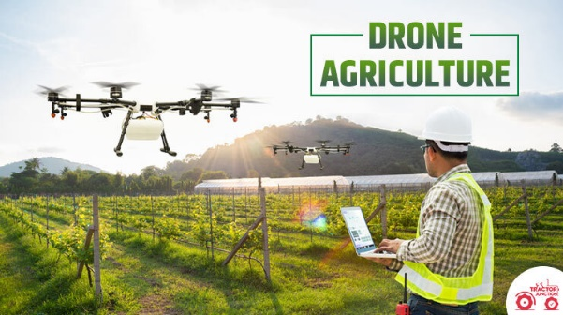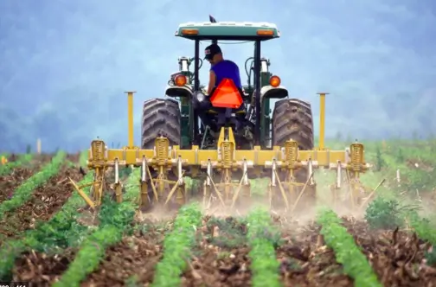

**CROP PRODUCTION IN INDIA**

The Final Estimates of production of major crops for the year 2022-23 have been released by the Department of Agriculture and Farmers Welfare. As per Final Estimates for 2022-23, total Foodgrain production in the country is estimated at record 3296.87 Lakh tonnes which is higher by 140.71 Lakh tonnes than the production of foodgrains of 3156.16 Lakh tonnes achieved during 2021-22. Further, the production during 2022-23 is higher by 308.69 Lakh tonnes than the previous five years’ (2017-18 to 2021-22) average production of foodgrains.

India is the second largest producer of rice, wheat, cotton, sugarcane, farmed fish, sheep & goat meat, fruit, vegetables and tea. The country has some 195 m ha under cultivation of which some 63 percent are rainfed (roughly 125m ha) while 37 percent are irrigated (70m ha).

Share of agriculture in India's GDP declined to 15 per cent last fiscal year from 35 per cent in 1990-91 due to rapid growth in the industrial and service sector, the government informed on Tuesday. "The share of agriculture in total Gross Value Added (GVA) of economy has declined from 35% in 1990-91 to 15% in 2022-23.

"With a population of just over 1.3 billion, India is the world's largest democracy. In the past decade, the country has witnessed accelerated economic growth, emerged as a global player with the world's fourth largest economy in purchasing power parity terms, and made progress towards achieving most of the Millennium Development Goals. India's integration into the global economy has been accompanied by impressive economic growth that has brought significant economic and social benefits to the country. Nevertheless, disparities in income and human development are on the rise. Preliminary estimates suggest that in 2009–10 the combined all India poverty rate was 32 % compared to 37 % in 2004–05. Going forward, it will be essential for India to build a productive, competitive, and diversified agricultural sector and facilitate rural, non-farm entrepreneurship and employment. Encouraging policies that promote competition in agricultural marketing will ensure that farmers receive better prices."

Since 2002, India has become the world's largest manufacturer of tractors with 29% of world's output in 2013; it is also the world's largest tractor market. Above, a tractor in Rewari, Haryana.

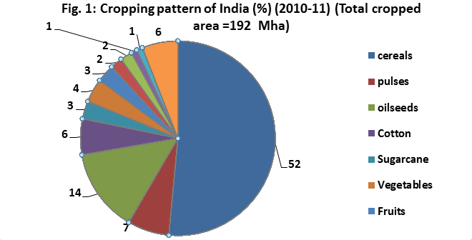

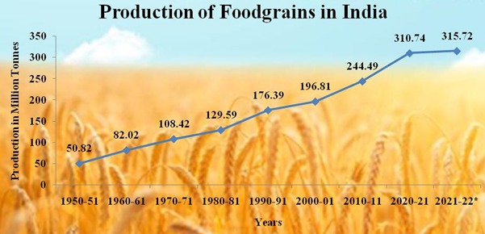

In 2017-18, total food grain production was estimated at 275 million tonnes (MT). India is the largest producer (25% of global production), consumer (27% of world consumption) and importer (14%) of pulses in the world.In India almost 60 percent of the total land area is used for agricultural purpose.About 58% of the Indian population depends on agriculture for their livelihood.

Union Agriculture and Farmers Welfare Minister Shri Narendra Singh Tomar has said on the record production of food grains that our farmer brothers and sisters are continuously working hard, while agricultural scientists and institutions are also doing very good work, along with this Under the leadership of Prime Minister Shri Narendra Modi, the Ministry of Agriculture is smoothly implementing the schemes and programs, thus everyone's efforts are reflecting better results in the agriculture sector including record food grains production.

As per Final Estimates, the estimated production of major crops during 2022-23 is as under:

Foodgrains – 3296.87 Lakh tonnes.

Rice – 1357.55 Lakh tonnes.

Wheat – 1105.54 Lakh tonnes.

Nutri / Coarse Cereals – 573.19 Lakh tonnes.

Maize – 380.85 Lakh tonnes.

Pulses – 260.58 Lakh tonnes.

Tur – 33.12 Lakh tonnes.

Gram – 122.67 Lakh tonnes.

Oilseeds – 413.55 Lakh tonnes.

Groundnut – 102.97 Lakh tonnes.

Soyabean – 149.85 Lakh tonnes.

Rapeseed and Mustard – 126.43 Lakh tonnes.

Sugarcane – 4905.33 Lakh tonnes.

Cotton – 336.60 Lakh bales (of 170 kg each)

Jute & Mesta – 93.92 Lakh bales (of 180 kg each)

For the vast majority of people living in the Middle Ages, the cultivation of wheat, barley, rye, and oats was fundamental to survival. Baked into bread, it was the staple of their diet.

And the crop growing percentage is different for every 1 decade and different methods were for agriculture in different times. Crop production is increased now comparing to last 2 or 3 decades.

**STATE WISE AGRICULTURAL LAND**

In different states different types of crops are grown according to thier climatic conditions and the soil. So, there is some information about some states of India and which type of crops do they grow.

**Uttar Pradesh**: Uttar Pradesh is one of the largest states in terms of agricultural land area in India. It has extensive plains and fertile regions, making agriculture a significant contributor to the state's economy.

**Madhya Pradesh**: Madhya Pradesh is known as the "heart of India" and has substantial agricultural land, with a focus on food grain production, oilseeds, and pulses.

**Maharashtra**: Maharashtra, particularly the western part of the state, has a significant amount of agricultural land. It is known for the production of sugarcane, cotton, fruits, and vegetables.

**Rajasthan**: Despite being a predominantly arid state, Rajasthan still has sizable agricultural land, primarily in the form of rain-fed farming and animal husbandry.

**West Bengal**: West Bengal has a substantial amount of agricultural land, especially in the Gangetic plains region. Rice cultivation is predominant here.

**Bihar**: Agriculture is the backbone of Bihar's economy, and the state has extensive agricultural land, primarily used for rice, wheat, maize, and pulses cultivation.

**Andhra Pradesh**: Andhra Pradesh has significant agricultural land, particularly in the coastal regions and the fertile Godavari and Krishna river deltas. It is known for rice, sugarcane, and horticultural crops.

**Punjab**: Punjab is known as the "granary of India" and has fertile agricultural land, primarily in the Indo-Gangetic plains. It is a major producer of wheat, rice, and fruits.

**Haryana:** Haryana has a significant amount of agricultural land, especially in the northern and western parts of the state. It is known for wheat, rice, cotton, and horticultural crops.

**Gujarat**: Gujarat has diverse agro-climatic conditions, leading to a variety of crops. It has substantial agricultural land used for cotton, groundnut, wheat, and fruits.

**Tamil Nadu**: Tamil Nadu has fertile agricultural land, particularly in the Cauvery delta region. It is known for rice, sugarcane, cotton, and horticultural crops.

**Karnataka**: Karnataka has diverse agricultural land, with a focus on cash crops like sugarcane, coffee, tea, and spices in addition to traditional food crops.

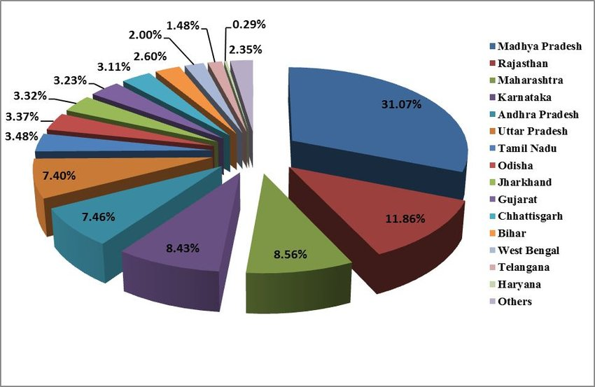

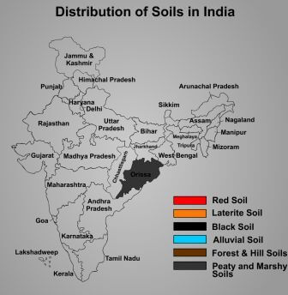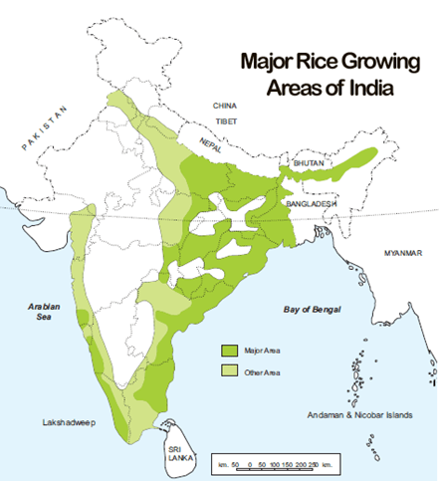

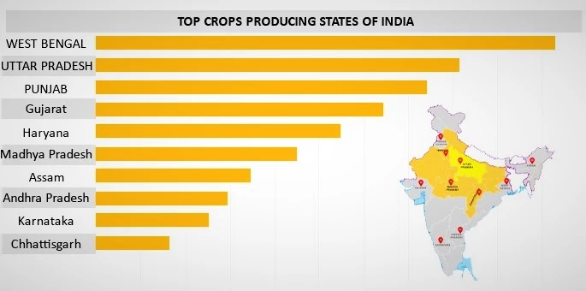

**AREA VS PRODUCTION**

The relationship between area and production in Indian agriculture is crucial for understanding productivity levels, efficiency, and agricultural performance.

**Area Under Cultivation**: This refers to the total land area being used for agricultural purposes, including both cropped area and fallow land. It is measured in hectares or acres and indicates the extent of land being utilized for agricultural activities.

**Crop Production**: Crop production refers to the quantity of crops harvested from the cultivated area within a specific time frame, usually measured in terms of weight (e.g., tonnes or kilograms). It reflects the output or yield obtained from the land under cultivation.

India is the largest producer (25% of global production), consumer (27% of world consumption) and importer (14%) of pulses in the world. India's annual milk production was 165 MT (2017-18), making India the largest producer of milk, jute and pulses, and with world's second-largest cattle population 190 million in 2012.

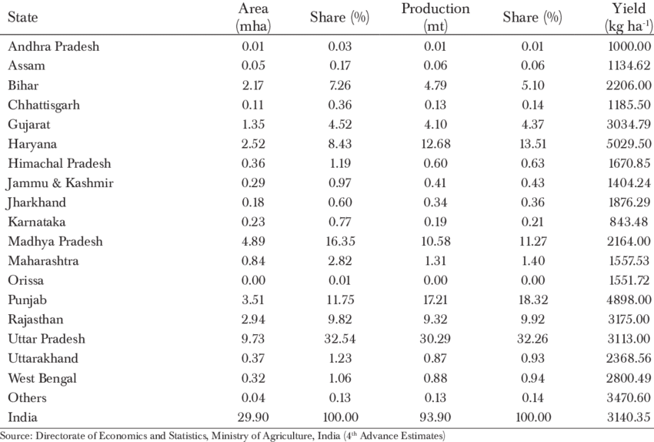

Uttar Pradesh is India's top farming state, with considerable state-level crop production including bajra, rice, sugarcane, food grains, and many others. It ranks first among India's wheat-producing states, ahead of Haryana, Punjab, and Madhya Pradesh.

Some of the major crop-producing states in India include Uttar Pradesh for sugarcane, Punjab for wheat and paddy, Andhra Pradesh for tobacco, Karnataka for coffee, and Maharashtra for grapes and sugarcane. The State of Andhra Pradesh is known as the rice bowl of India. Rice makes up to 77 percent of the total crop production.

Top 10 Agricultural Lands in India

Andhra Pradesh

Assam

Gujarat

Haryana

Karnataka

Punjab

Uttar Pradesh

West Bengal

Chattisgarh

Maharashtra

**SEASON BASED CULTIVATION**

Season-based cultivation refers to the practice of growing crops according to specific seasons or periods of the year, taking into account factors such as temperature, rainfall, and day length. In India, where agriculture is heavily dependent on monsoon rains and diverse climatic conditions, season-based cultivation plays a crucial role in maximizing agricultural productivity. Here's an overview of the main seasons and the types of crops typically cultivated during each season:

**Kharif Season (Monsoon Season):**

Duration: June to September

Crops: Kharif crops are sown with the onset of the monsoon rains and harvested in the autumn. These crops are typically rain-fed and include:

Rice

Maize

Millets (such as jowar, bajra, and ragi)

Cotton

Soybeans

Groundnuts

Sugarcane

Pulses (such as pigeon pea, green gram, and black gram)

**Rabi Season (Winter Season):**

Duration: October to March

Crops: Rabi crops are sown in the winter season and harvested in spring. These crops rely on irrigation and include:

Wheat

Barley

Mustard

Gram (chickpeas)

Lentils

Peas

Linseed

Potatoes

Vegetables (such as carrots, onions, and cauliflower)

**Zaid Season (Summer Season):**

Duration: March to June

Crops: Zaid crops are grown during the summer season, often between the harvesting of Rabi crops and the sowing of Kharif crops. These crops are relatively short-duration and include:

Cucumbers

Watermelons

Muskmelons

Bitter gourd

Pumpkin

Bottle gourd

Maize

Green gram

Black gram

Each season has its own set of crops that are well-suited to the prevailing climatic conditions and available water resources. Farmers often plan their cropping patterns based on these seasons, rotating crops to maintain soil fertility, manage pests and diseases, and optimize water usage. Additionally, season-based cultivation allows farmers to stagger their harvests, ensuring a continuous supply of crops throughout the year and reducing the risks associated with dependency on a single cropping season.

Effective planning and management of season-based cultivation are essential for maximizing agricultural productivity, enhancing food security, and improving rural livelihoods in India. This includes selecting appropriate crop varieties, optimizing input use, implementing water-saving techniques, and adopting climate-smart agricultural practices tailored to each season's requirements.

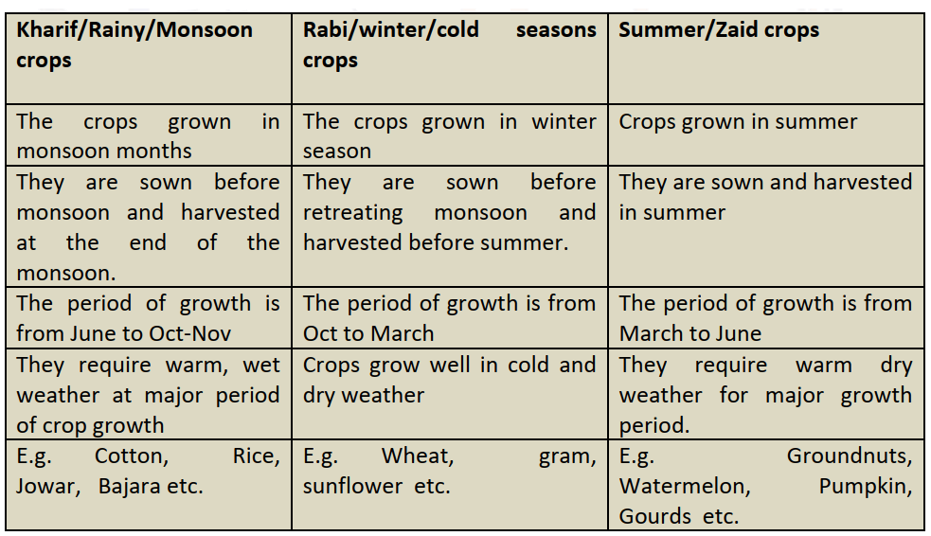

**YIELD BY SEASON**

Yield by season refers to the quantity of crops harvested per unit of land during specific agricultural seasons. The yield is a key indicator of agricultural productivity and reflects the efficiency of crop production practices, input usage, and environmental conditions during each season. Here's an overview of yield patterns by season in Indian agriculture:

**Kharif Season (Monsoon Season):**

Yield: The yield in the Kharif season can vary significantly depending on factors such as the distribution and amount of rainfall, soil fertility, and pest and disease pressure.

Factors Affecting Yield: Adequate and well-distributed rainfall is crucial for optimal Kharif crop yields. Variability in monsoon rainfall patterns can lead to fluctuations in yield levels across regions.

Yield Examples: In regions with favorable monsoon conditions, Kharif crops like rice, maize, and cotton can achieve relatively high yields per hectare.

**Rabi Season (Winter Season):**

Yield: Rabi crop yields tend to be more stable compared to Kharif crops due to the availability of irrigation water during the winter season.

Factors Affecting Yield: Adequate irrigation, favorable temperature and moisture conditions, and proper crop management practices contribute to higher Rabi crop yields.

Yield Examples: Crops like wheat, barley, and mustard often achieve good yields during the Rabi season, especially in regions with reliable irrigation infrastructure.

**Zaid Season (Summer Season):**

Yield: Zaid crops are typically short-duration crops grown during the summer season, and their yields can vary depending on factors such as water availability, temperature, and pest pressure.

Factors Affecting Yield: Adequate irrigation, temperature management, and timely pest and disease control are essential for maximizing Zaid crop yields.

Yield Examples: Crops like cucumbers, watermelons, and muskmelons can achieve good yields during the Zaid season under favorable growing conditions.

Overall, yield by season reflects the interplay of various factors including climatic conditions, soil fertility, crop selection, agricultural practices, and management decisions. Farmers often adapt their cropping patterns and agronomic practices to optimize yields during each season, aiming to maximize agricultural productivity and profitability. Additionally, advancements in technology, irrigation infrastructure, crop varieties, and crop management practices continue to contribute to improved yields across different seasons in Indian agriculture.

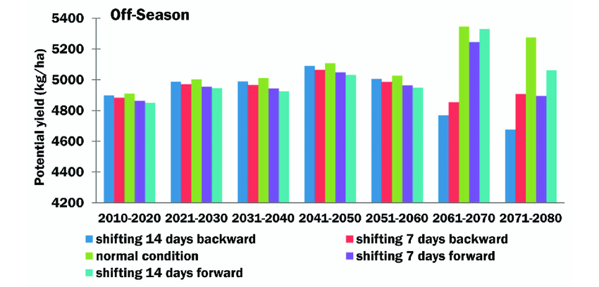

**CROP PLANTATION BY AREA**

Crop plantation by area refers to the distribution of different crops across agricultural land in a particular region or country. In India, the cropping pattern varies widely across different states and regions due to diverse agro-climatic conditions, soil types, water availability, and farmer preferences. Here's an overview of the major crops and their respective areas of cultivation in India:

**Rice:**

Rice is predominantly grown in the eastern and southern parts of India, including states like West Bengal, Uttar Pradesh, Andhra Pradesh, Tamil Nadu, and Odisha.

Major rice-growing regions include the fertile Gangetic plains, coastal deltas (such as the Godavari and Krishna deltas), and regions with abundant irrigation facilities.

**Wheat**:

Wheat cultivation is concentrated in the northwestern states of Punjab, Haryana, and parts of Uttar Pradesh and Rajasthan.

The Indo-Gangetic plains, with their fertile alluvial soil and well-developed irrigation infrastructure, are ideal for wheat cultivation.

**Maize:**

Maize cultivation is widespread across India, with major producing states including Karnataka, Andhra Pradesh, Telangana, Maharashtra, Uttar Pradesh, and Bihar.

Maize is grown both as a Kharif and Rabi crop, with variations in planting seasons and growing conditions depending on the region.

**Millet (Jowar, Bajra, Ragi):**

Millets are primarily grown in the semi-arid regions of central and western India, including states like Maharashtra, Karnataka, Rajasthan, Gujarat, and Tamil Nadu.

These crops are well-suited to regions with limited rainfall and poor soil fertility, where they serve as important staples for food security.

**Pulses (Pigeon Pea, Chickpea, Lentils):**

Pulse cultivation is widespread across India, with major producing states including Madhya Pradesh, Uttar Pradesh, Maharashtra, Rajasthan, and Karnataka.

Pulses are grown in diverse agro-climatic zones, including both rain-fed and irrigated areas.

**Cotton:**

Cotton is primarily grown in the central and western states of India, including Gujarat, Maharashtra, Andhra Pradesh, Telangana, and Madhya Pradesh.

The cotton belt of India, comprising regions like Vidarbha in Maharashtra and the cotton-growing districts of Gujarat, is known for its cotton cultivation.

**Sugarcane:**

Sugarcane cultivation is concentrated in the tropical and subtropical regions of India, including states like Uttar Pradesh, Maharashtra, Karnataka, Tamil Nadu, and Andhra Pradesh.

Sugarcane requires ample water and fertile soil, making it well-suited to regions with abundant rainfall or irrigation facilities.

**Oilseeds (Soybean, Groundnut, Mustard):**

Oilseed cultivation is spread across various states in India, with major producing regions including Madhya Pradesh, Maharashtra, Rajasthan, Gujarat, and Andhra Pradesh.

These crops are cultivated both as Kharif and Rabi crops, with variations in planting seasons and growing conditions.

These are just a few examples of major crops and their areas of cultivation in India. The cropping pattern may vary from year to year based on factors such as market demand, government policies, weather conditions, and technological advancements. Additionally, farmers often practice crop rotation and multiple cropping to optimize land use and enhance soil fertility, further influencing.

**Major Crops Growth**

As of last update in January 2022, I don't have access to real-time data, including year-on-year (YoY) growth figures for major crops in India. However, I can provide you with general insights into the trends and factors influencing the growth of major crops in the country.

The growth of major crops in India can be influenced by various factors including:

**Monsoon Patterns**: The performance of the monsoon greatly influences agricultural output in India, as a significant portion of the country's agriculture is rain-fed. Adequate and well-distributed rainfall is crucial for crop growth, while deficient or erratic rainfall can lead to yield losses.

**Government Policies**: Government policies related to minimum support prices (MSPs), procurement mechanisms, subsidies, and agricultural credit can impact farmers' decisions regarding crop selection and production levels. Policy interventions aimed at promoting specific crops or providing support during price fluctuations can influence their growth.

**Input Costs and Availability**: Factors such as the cost and availability of seeds, fertilizers, pesticides, and irrigation facilities affect farmers' input decisions and crop yields. Fluctuations in input prices and availability can impact crop production costs and profitability.

**Market Demand and Prices:** Market demand and prices for agricultural commodities play a significant role in farmers' decisions regarding crop selection and production levels. High market prices may incentivize increased production, while low prices may lead to reduced cultivation.

**Technological Advancements:** Adoption of modern agricultural technologies, improved crop varieties, mechanization, and precision farming techniques can enhance crop productivity and contribute to growth in agricultural output.

**Pests and Diseases:** Outbreaks of pests and diseases can significantly impact crop yields if not effectively managed through pest control measures and timely interventions.

**Global Factors:** International factors such as global commodity prices, trade policies, and weather patterns in major agricultural producing countries can also influence crop growth and prices in India.

To obtain the most accurate and up-to-date year-on-year growth figures for major crops in India, you may refer to reports and publications from government agencies such as the Ministry of Agriculture and Farmers' Welfare, agricultural universities, research institutions, and agricultural surveys conducted by organizations like the National Sample Survey Office (NSSO) or the Ministry of Statistics and Programme Implementation (MoSPI). These sources typically provide comprehensive data and analysis on agricultural production, yields, and growth trends at both national and state levels.e distribution of crops across agricultural land.

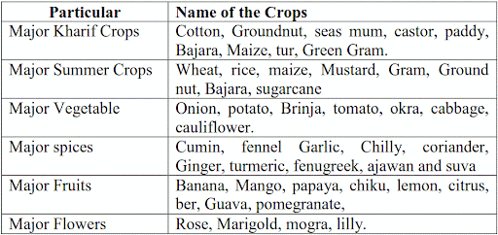

**CROPS**

Here's a list of some major crops cultivated in India:

**Rice:** A staple food crop, extensively grown in regions with high rainfall or irrigation facilities.

**Wheat:** Another staple food crop, mainly cultivated in the northwestern plains of India during the Rabi season.

**Maize (Corn):** Grown in diverse agro-climatic conditions, used for human consumption, animal feed, and industrial purposes.

**Millets (Jowar, Bajra, Ragi):** Drought-resistant crops, commonly grown in semi-arid regions, serve as important food grains and fodder.

**Pulses (Chickpeas, Pigeon Pea, Lentils):** Rich in protein, cultivated in both rain-fed and irrigated areas, essential for vegetarian diets.

**Cotton:** A major cash crop grown in the central and western regions, used for textile manufacturing and oil extraction.

**Sugarcane:** Grown in tropical and subtropical regions for sugar production and ethanol.

**Oilseeds (Soybean, Groundnut, Mustard):** Rich sources of edible oils, grown across various agro-climatic zones.

**Tea and Coffee:** Cultivated in specific regions with suitable altitude, rainfall, and temperature conditions.

**Spices (Cardamom, Pepper, Turmeric):** Grown in diverse regions, India is a major producer and exporter of spices.

**Fruits (Mangoes, Bananas, Citrus):** Grown in orchards across the country, contributing to both domestic consumption and export markets.

**Vegetables (Tomatoes, Onions, Potatoes):** Cultivated in diverse agro-climatic conditions, meeting the dietary needs of the population.

These are just a few examples, and India cultivates a wide variety of crops owing to its diverse agro-climatic conditions and rich agricultural heritage. Each crop has its own specific cultivation requirements, growing seasons, and significance in the agricultural economy.

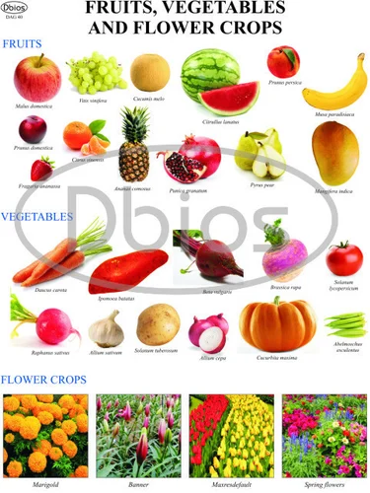

**SEASON WISE PRODUCTION**

Here's a general overview of season-wise production for some major crops in India:

**Kharif Season (Monsoon Season):**

Rice: Kharif season is the main season for rice cultivation in India. States like West Bengal, Uttar Pradesh, Andhra Pradesh, and Odisha are major rice-producing regions during this season.

Maize: Maize is another significant Kharif crop, cultivated in states like Karnataka, Andhra Pradesh, Telangana, Maharashtra, and Madhya Pradesh.

Cotton: Cotton cultivation predominantly takes place during the Kharif season, with major producing states including Gujarat, Maharashtra, Andhra Pradesh, Telangana, and Karnataka.

**Rabi Season (Winter Season):**

Wheat: Rabi season is the primary season for wheat cultivation in India, with major producing states including Punjab, Haryana, Uttar Pradesh, and Madhya Pradesh.

Barley: Barley is another important Rabi crop grown in states like Rajasthan, Uttar Pradesh, Madhya Pradesh, and Haryana.

Mustard: Mustard cultivation is predominant during the Rabi season, with major producing states including Rajasthan, Uttar Pradesh, Madhya Pradesh, and Haryana.

**Zaid Season (Summer Season):**

Mangoes,Cucumbers, watermelons, muskmelons, and other vegetables: Zaid season is suitable for the cultivation of various summer vegetables and fruits in states across India. These crops are typically grown in regions with sufficient irrigation facilities and suitable climatic conditions.

While this provides a general overview of season-wise production for some major crops, it's important to note that cropping patterns and production levels can vary from year to year based on factors such as weather conditions, government policies, market demand, and technological advancements. Additionally, India's diverse agro-climatic zones result in a wide range of crops being cultivated throughout the year, contributing to the country's agricultural diversity and resilience. For more detailed and up-to-date information on season-wise production for specific crops, you may refer to agricultural reports, surveys, and data published by government agencies and research institutions.

**KPI'S**

Key Performance Indicators (KPIs) are measurable values that demonstrate how effectively a company, organization, or individual is achieving key business objectives. In the context of agriculture, here are some examples of KPIs that are commonly used to assess the performance and effectiveness of farming operations:

**Yield per Hectare/Acre:** This KPI measures the quantity of crops harvested per unit of land area, indicating the productivity and efficiency of agricultural production.

**Crop Growth Rate**: Crop growth rate is a measure of the increase in crop biomass over time, reflecting the growth and development of crops throughout the growing season.

**Water Use Efficiency:** Water use efficiency measures the amount of water used to produce a unit of crop yield, indicating how efficiently water resources are being utilized in agricultural operations.

**Input Efficiency:** Input efficiency KPIs assess the effectiveness of inputs such as seeds, fertilizers, pesticides, and labor in producing desired agricultural outputs, aiming to minimize waste and maximize productivity.

**Crop Diversity Index:** This KPI measures the diversity of crops grown on a farm or agricultural land, promoting resilience to pests, diseases, and market fluctuations while enhancing soil health and biodiversity.

**Cost of Production:** Cost of production KPIs evaluate the total expenses incurred in agricultural operations relative to the quantity and value of crops produced, helping to optimize resource allocation and maximize profitability.

**Gross Margin:** Gross margin measures the difference between total revenue generated from crop sales and the variable costs associated with crop production, providing insight into the profitability of farming activities.H5CkTQdF

**Labor Productivity:** Labor productivity KPIs assess the efficiency of labor utilization in agricultural operations, measuring the output per unit of labor input (e.g., labor hours or labor costs).

**Crop Quality Metrics:** Crop quality metrics evaluate the physical, chemical, and nutritional characteristics of harvested crops, ensuring compliance with market standards and consumer preferences.

**Sustainability Indicators:** Sustainability indicators assess the environmental, social, and economic impacts of agricultural practices, including soil health, carbon footprint, biodiversity conservation, and community well-being.

**Market Share:** Market share KPIs measure the percentage of total market sales or production volume captured by a farm or agricultural enterprise, indicating its competitive position and market influence.

**Customer Satisfaction:** Customer satisfaction KPIs assess the level of satisfaction among stakeholders such as buyers, consumers, and community members, reflecting the perceived quality and value of agricultural products and services.

These are just a few examples of KPIs that can be used to measure and evaluate performance in agriculture. The selection of KPIs depends on the specific goals, objectives, and priorities of the farming operation, as well as external factors such as market dynamics, regulatory requirements, and sustainability considerations.

**Responsiveness And Design Of Dashboard**

Designing a dashboard involves balancing functionality with aesthetics. Here are some key aspects to consider:

**User-Centric Design**: Understand your users' needs and preferences. Design the dashboard in a way that makes it intuitive and easy to use for them.

**Responsive Design**: Ensure the dashboard is responsive across various devices and screen sizes. Users should be able to access and interact with the dashboard seamlessly on desktops, laptops, tablets, and mobile devices.

**Clear Navigation**: Use a clear and intuitive navigation structure that helps users easily find the information they need. Consider using menus, tabs, or icons to organize content logically.

**Visual Hierarchy**: Use visual elements such as color, typography, and spacing to create a clear hierarchy of information. Important data should be prominently displayed, while less critical information can be de-emphasized.

**Consistency**: Maintain consistency in design elements such as color scheme, typography, and layout across the dashboard to provide a cohesive user experience.

**Interactive Elements**: Incorporate interactive elements such as filters, dropdowns, and buttons to allow users to manipulate and explore data dynamically.

**Data Visualization**: Choose appropriate data visualization techniques such as charts, graphs, and tables to effectively communicate information. Ensure that visualizations are easy to understand and interpret.

**Performance**: Optimize the dashboard for performance to ensure fast loading times and smooth interactions, especially when dealing with large datasets.

**Accessibility**: Make sure the dashboard is accessible to users with disabilities by following accessibility guidelines and standards.

**Feedback Mechanism**: Include feedback mechanisms such as surveys or contact forms to gather user feedback and improve the dashboard over time.

By focusing on responsiveness and thoughtful design, you can create a dashboard that not only looks visually appealing but also provides valuable insights to users in an efficient manner.

A dashboard is a collection of several views, letting you compare a variety of data simultaneously. For example, if you have a set of views that you review every day, you can create a dashboard that displays all the views at once, rather than navigate to separate worksheets.

Like worksheets, you access dashboards from tabs at the bottom of a workbook. Data in sheets and dashboards is connected; when you modify a sheet, any dashboards containing it change, and vice versa.

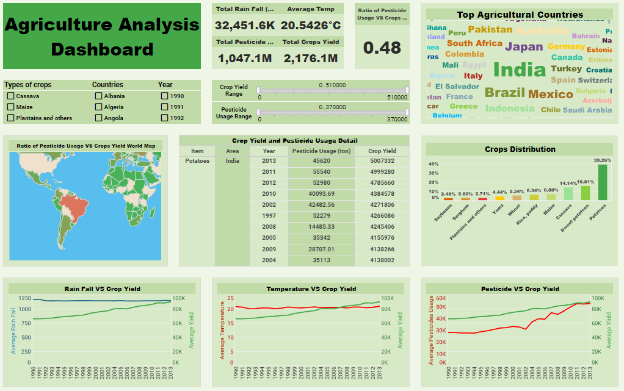

The given dashboard is about the agriculture analysis dashboard.It shows about the agriculture countries,rain fall,temperature,pesticides,crops distribution etc.

Designing a dashboard for Indian agriculture would involve incorporating various aspects related to crop production, weather patterns, market trends, government policies, and more. Here's a breakdown of components you might include:

**Crop Production Overview:**

Visual representation of major crops cultivated across different states.

Yearly trends in crop production.

Comparison of current year's production with previous years.

**Weather Data:**

Real-time or historical weather data relevant to agriculture, including temperature, rainfall, humidity, and wind speed.

Seasonal forecasts and predictions.

Impact of weather patterns on crop yields.

**Market Trends:**

Prices of key agricultural commodities in major markets.

Price trends over time for different crops.

Market demand-supply dynamics.

**Government Schemes and Policies:**

Overview of government schemes related to agriculture.

Information on subsidies, loans, and grants available to farmers.

Updates on policy changes affecting agriculture.

**Crop Health Monitoring:**

Satellite imagery or drone data to assess crop health.

Detection of pests, diseases, and other threats to crops.

Recommendations for pest control and disease management.

**Land Use and Irrigation:**

Distribution of agricultural land across different regions.

Availability and utilization of irrigation facilities.

Water management practices and initiatives.

**Farmers' Assistance and Education:**

Access to agricultural extension services and resources.

Training programs and workshops for farmers.

Information on best agricultural practices.

**Livestock and Fisheries:**

Data on livestock population and production.

Trends in fisheries and aquaculture.

Support services for livestock and fisheries sectors.

**Export-Import Data:**

Export and import statistics for agricultural products.

Trade agreements and tariffs affecting agricultural exports.

**Customizable Filters and Interactivity:**

Filters to allow users to view data by region, crop type, time period, etc.

Interactive charts and maps for data exploration.

User-friendly interface with intuitive navigation.

**Feedback and Support:**

Mechanism for farmers to provide feedback or seek assistance.

Links to relevant resources, helplines, and support services.

**Mobile Compatibility and Alerts:**

Mobile-friendly design for access on smartphones.

Push notifications or alerts for critical updates or weather warnings.

By integrating these elements into a comprehensive dashboard, stakeholders in Indian agriculture, including farmers, policymakers, researchers, and agricultural businesses, can gain valuable insights and make informed decisions to improve productivity and sustainability in the sector.

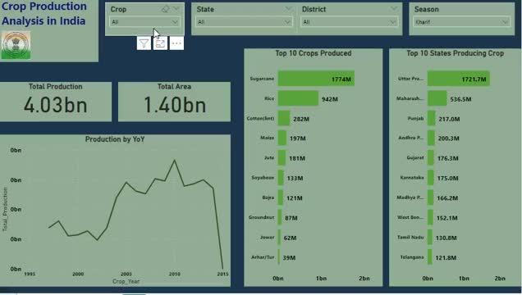

The given dashboard is about the crop production analysis in India.In this they have given about the total production and total area.The top 10 crops produced are;

Sugarcane

Rice

Cotton

Maize

Jute

Soyabean

Bajra

Groundnut

Jowar

Arhar

The top 10 crop producing states are;

Uttar Pradesh

Maharashtra

Punjab

Andhra Pradesh

Gujarat

Karnataka

Madhya Pradesh

West Bengal

Tamil Nadu

Telangana

**STORY**

A data story is a way of presenting data and analysis in a narrative format, with the goal of making the information more engaging and easier to understand. A data story typically includes a clear introduction that sets the stage and explains the context for the data, a body that presents the data and analysis in a logical and systematic way, and a conclusion that summarizes the key findings and highlights their implications. Data stories can be told using a variety of mediums, such as reports, presentations, interactive visualizations, and videos.

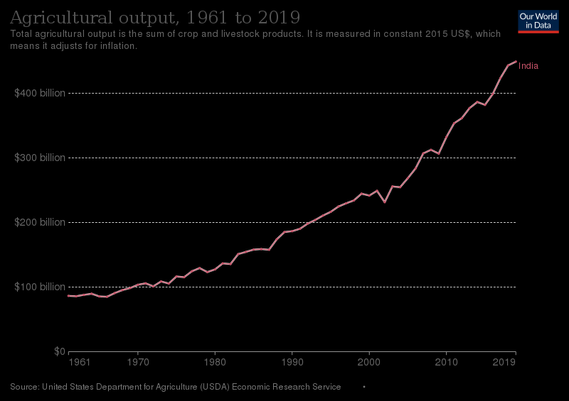

As of my last update in January 2022, India's agriculture sector plays a crucial role in the country's economy and is a significant contributor to its GDP. The agriculture output of India encompasses a wide range of crops, including rice, wheat, pulses, fruits, vegetables, sugarcane, cotton, and more. India is one of the world's largest producers of rice and wheat.

However, specific figures for agriculture output can vary year by year due to factors such as weather conditions, government policies, and market dynamics. For the most current and accurate data on India's agriculture output, it's best to refer to reports from authoritative sources such as the Ministry of Agriculture & Farmers' Welfare, the Food and Agriculture Organization (FAO), or other relevant government agencies and international organizations.

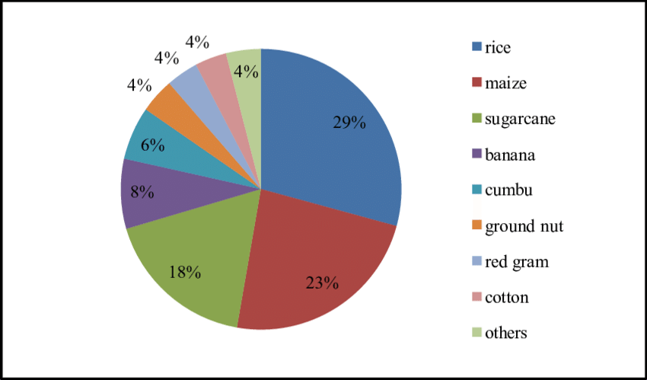

India has a diverse range of crops cultivated across different regions due to variations in climate, soil types, and other geographical factors. The percentage area of cultivation for different crops can fluctuate based on various factors such as government policies, market demand, and climatic conditions. However, here are some general trends in the percentage area of cultivation for major crops in India:

Rice: Rice is predominantly cultivated in states like West Bengal, Uttar Pradesh, Andhra Pradesh, Punjab, and Tamil Nadu. It occupies a significant percentage of the total cultivated area in these states.

Wheat: Wheat cultivation is widespread in states like Punjab, Haryana, Uttar Pradesh, Madhya Pradesh, and Rajasthan. It is one of the staple food crops in India.

Millets: Millets such as bajra, jowar, and ragi are grown in states like Rajasthan, Maharashtra, Karnataka, and Andhra Pradesh. These crops are important for food security and are often cultivated in arid and semi-arid regions.

Pulses: Pulses like chickpeas, lentils, and pigeon peas are cultivated in various states across India, including Madhya Pradesh, Maharashtra, Rajasthan, and Uttar Pradesh. Pulses are essential for providing protein in the Indian diet.

Sugarcane: Sugarcane cultivation is prominent in states like Uttar Pradesh, Maharashtra, Karnataka, Tamil Nadu, and Andhra Pradesh. India is one of the largest producers of sugarcane in the world.

Cotton: Cotton cultivation is concentrated in states like Gujarat, Maharashtra, Andhra Pradesh, Punjab, and Haryana. Cotton is a crucial cash crop for many farmers in India.

Fruits and Vegetables: India cultivates a wide variety of fruits and vegetables across different states. States like Maharashtra, Uttar Pradesh, Andhra Pradesh, Karnataka, and Tamil Nadu are significant producers of fruits and vegetables.

These percentages can vary from year to year based on factors such as government policies, market demand, and weather conditions. For the most up-to-date information on the percentage area of cultivation for different crops in India, it's advisable to refer to reports from authoritative sources such as the Ministry of Agriculture & Farmers' Welfare or other relevant government agencies.

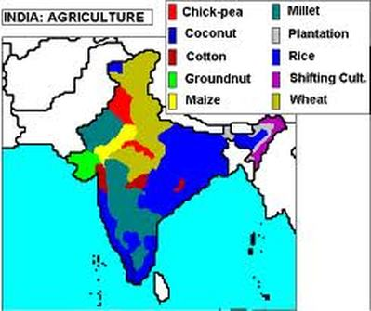

Punjab:

Wheat

Rice

Barley

Maize

Mustard

Haryana:

Wheat

Rice

Sugarcane

Cotton

Mustard

Uttar Pradesh:

Rice

Wheat

Sugarcane

Potato

Maize

Maharashtra:

Sugarcane

Cotton

Rice

Pulses

Oilseeds

Fruits (Mango, Grapes)

Madhya Pradesh:

Wheat

Soybean

Maize

Gram (Chickpeas)

Pulses

Andhra Pradesh:

Rice

Sugarcane

Cotton

Maize

Pulses

Tamil Nadu:

Rice

Sugarcane

Cotton

Pulses

Oilseeds

Karnataka:

Rice

Sugarcane

Cotton

Maize

Pulses

Fruits (Banana, Mango)

Gujarat:

Cotton

Groundnut

Rice

Sugarcane

Pulses

Rajasthan:

Wheat

Barley

Pulses

Oilseeds

Millets (Bajra, Jowar)

**PERFORMANCE TESTING**

**NO. OF CALCULATION FIELDS**

The number of cultivated fields in India is vast and constantly changing due to factors such as land fragmentation, urbanization, and agricultural practices. In rural areas, small-scale farmers often cultivate relatively small plots of land, while larger agricultural enterprises may manage much larger fields.

The exact number of cultivated fields across India is difficult to determine precisely due to the vastness of the country and the variability in agricultural practices from region to region. It would require detailed surveys and data collection efforts by agricultural authorities to accurately quantify the total number of cultivated fields.

If you need specific statistical data on the number of cultivated fields in India, I would recommend consulting reports and databases from government agricultural departments or organizations like the Ministry of Agriculture & Farmers' Welfare or the National Sample Survey Office (NSSO). They may provide more detailed information on agricultural land use and cultivation patterns in India.

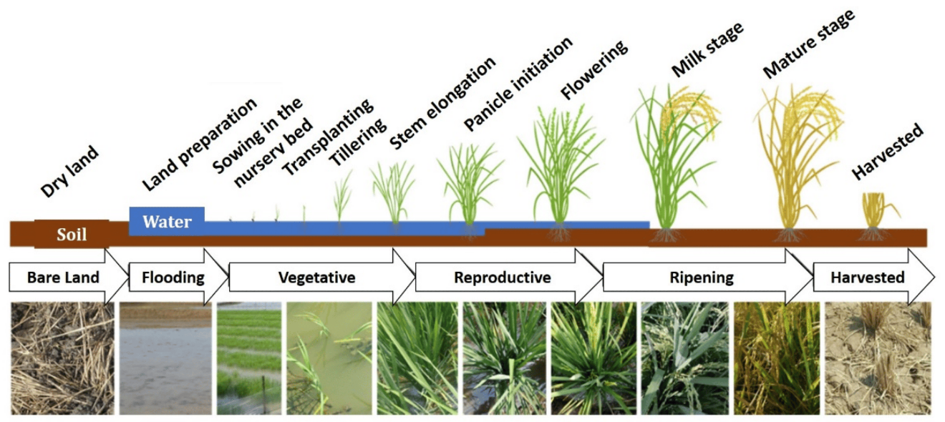

**NO.OF VISUALIZATIONS**

What are the problems faced in agriculture?

No. of crops grown in India

Types of soil and crops

Top 10 crop producing states

History of Indian agriculture

Crops grown in States of India

Which type of crop grown in different states

**WEB INTEGRATION**



Crop production analysis in India involves examining various factors that influence agricultural output, including crop yields, cultivation practices, weather patterns, market dynamics, government policies, and technological advancements. Here's an overview of the key aspects involved in crop production analysis:

**Crop Yields**: Analyzing crop yields helps understand the productivity of different crops in various regions of India. This analysis involves assessing historical yield data, identifying trends, and evaluating factors that contribute to yield variations, such as soil quality, irrigation facilities, use of fertilizers and pesticides, and adoption of improved agricultural practices.

**Cultivation Practices**: Examining cultivation practices provides insights into the methods employed by farmers, including cropping patterns, land preparation techniques, sowing methods, irrigation practices, and pest management strategies. Understanding these practices helps identify opportunities for optimization and improvement to enhance crop productivity and sustainability.

**Weather Patterns**: Weather plays a significant role in crop production, influencing factors such as planting dates, crop growth, pest and disease incidence, and harvesting schedules. Analyzing historical weather data and forecasting future weather patterns enable farmers and policymakers to make informed decisions regarding crop selection, timing of agricultural operations, and risk management strategies.

**Market Dynamics**: Analyzing market dynamics involves assessing factors such as supply and demand, price trends, export-import patterns, government procurement policies, and market infrastructure. Understanding market dynamics helps farmers make decisions regarding crop selection, marketing strategies, price negotiations, and risk mitigation measures.

**Government Policies**: Government policies, including agricultural subsidies, price support mechanisms, crop insurance schemes, and regulatory frameworks, significantly influence crop production and marketing. Analyzing the impact of existing policies and proposing policy recommendations based on empirical evidence and stakeholder consultations are essential for fostering a conducive environment for agricultural growth and sustainability.

**Technological Advancements**: Technological innovations, such as high-yielding crop varieties, precision agriculture techniques, mechanization, biotechnology, and digital farming solutions, play a crucial role in enhancing crop productivity, resource efficiency, and resilience to climate change. Evaluating the adoption and impact of these technologies on crop production and farmer livelihoods is essential for promoting sustainable agricultural development.

**Sustainability and Resilience**: Assessing the sustainability and resilience of crop production systems involves considering environmental, social, and economic factors. This analysis includes evaluating the use of natural resources, soil health management practices, biodiversity conservation efforts, climate change adaptation strategies, and socio-economic impacts on farming communities.

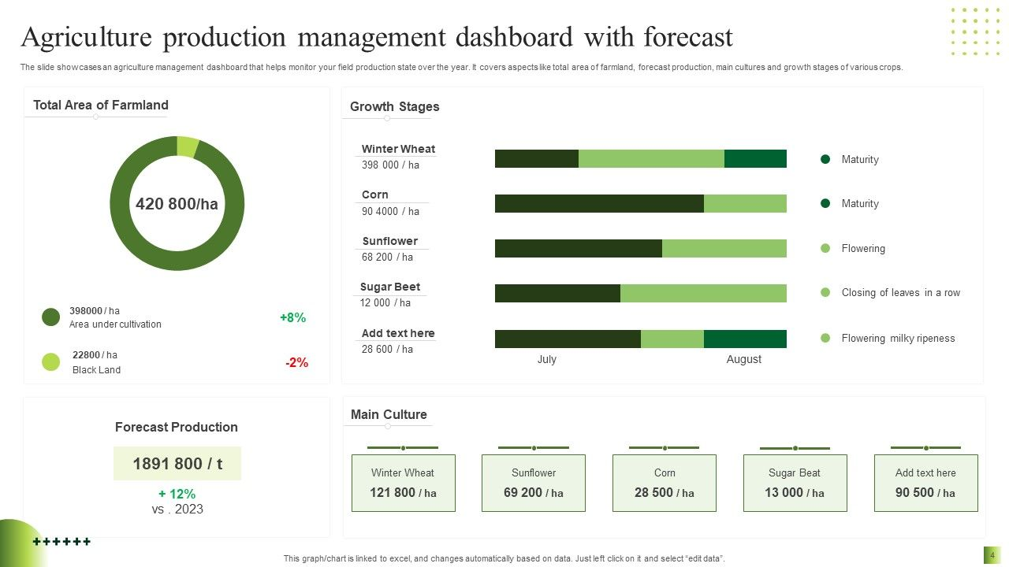

**THE END**